Duy Mai, Twan Tran, and Hoang-Uyen Tran

Department of Engineering, Cal State Long Beach University

CECS 450: Data Visualization

Dr. Anthony Giacalone

December 8, 2023

**What is the problem?**

The last decade, our earth has been facing global warming or the greenhouse effect known as climate change. Scientists have diligently documented global surface temperatures using thermometer-based records. This observed consistent rise in temperature is a clear indication of the changing climate. The emission of greenhouse gases (GHGs) such as CO2, CH4, and N2O. These GHGs act as a blanket in the Earth’s atmosphere, trapping heat and causing the temperature rise of Earth. The change in temperature may seem like a good sight for people living in the colder area of Earth because they will be experiencing a warmer winter than their usual cold weather. However, only one gain but many unpleasant situations come along with the temperature warmer such as: destruction in the marine life for species that live in the colder area of water that their habitat got destroyed. Melting of glaciers, rising sea level, extreme weather events, ocean acidification, disruption of ecosystems, and threat to water resources.

*Illustrate of Change in Temperature*

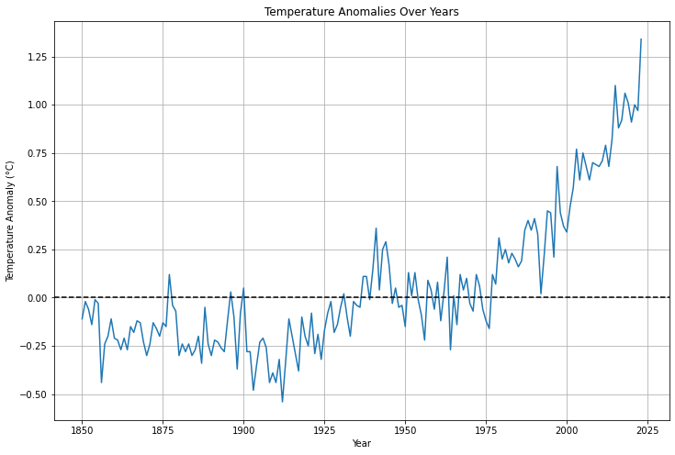

*Illustrate of Disasters*

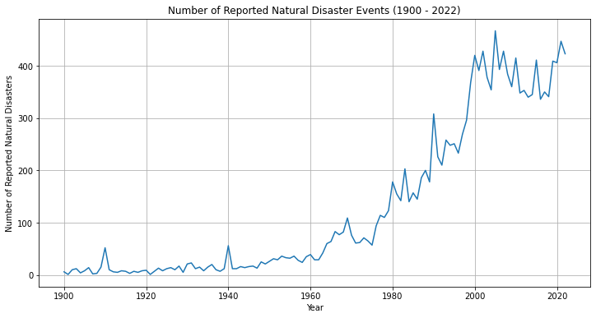

**Data Gather**

Global Carbon Atlas is the climate change resource center: Provides CO2 emissions data by country and industry (Lu, 2023). The article covers worldwide CO2 emissions per capita (metric tons) from 2021 to the future (e.g. 2050,2070). Our World in Data: Offers a wide range of environmental data including CO2 emissions (Ritchie, Roser, and Rosado, 2020). Carbon Brief: Global CO2 emissions could peak as soon as 2023, IEA data reveals (Evans and Viisainen, 2023). IMF: World Needs More Policy Ambition, Private Funds, and Innovation to Meet Climate Goals (Black, Jaumotte, and Ananthakrishan, 2023). Data about global CO2 emissions from fossil fuels, land use change, region, annual emission, per capita per country, emission change over time. Each data has its data record from 1750 to 2022 according to each country saves in a CVS data.

**Utilizing data**

CO2 Emissions by country specific in 2021 China was known as the most populous country in the world. The expectation for the emission level will be at least top 1 or 2, however the result came out unexpected that change initial hypothesis.

*Illustrate Global CO2 Emission by Country in 2021*

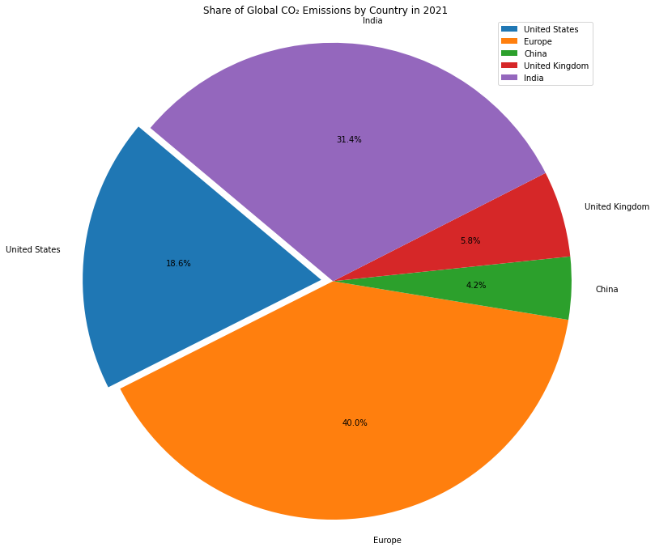

As the chart diagram shows that Europe is the country consumes the most CO2 Emission. European styles are vintage and still in the monarchy, so even the world is technologies development, but they keep most of their routine as back in the day such as: wood fireplace, fashion industry, appliances use. China having over 1.4 billion people, however for the last couple decade, China drastically develop from transportation, appliances use, and majority of their daily routine to technology and their goal is to fast and efficient. This change help decrease the bad breathing air in China. Untied State is the strongest country in development and technology, but only 18% of all the top nations. With the